**Learning Objectives**

* Describe the role of this course and this specialization within the computing field.
* Explain how the various components of the class (project, core, etc.) connect.
* Choose the path through the course which works well for you.
* Determine if this is the right course for you.
* Explain why classes and objects are useful in programming
* Create objects and call methods on them
* Describe member variables, methods and constructors
* Explain how to overload methods in Java and why overloading methods is useful
* Describe the meaning of the keywords public and private and their effect on where variables can be accessed

**After completing this course, you will be able to..**.

1. Author a class in Java and explain how objects are constructed, how they store data, and how you can define their actions.
2. Trace the execution of code using memory-models.
3. Define the scope of variables and methods.
4. Extend existing libraries to build a medium-sized project.
5. Implement user interface features.
6. Build and work with a class hierarchy that has multiple levels.
7. Explain “is-a” and “has-a” relationships between objects.
8. Author code which implements an Interface.
9. Explain the difference between compile-time and run-time decisions when working with polymorphism.
10. Explain the difference between event-driven programming and imperative programming.
11. Use searching and sorting to design algorithms for analyzing data.
12. Search for an element in a sorted and unsorted list and explain the differences.
13. Explain multiple sorting techniques and performance tradeoffs.

## **This Specialization is a Gateway into Computing**

You might be fairly new to computing and may not have a big-picture view of how ideas and topics come together in the huge field of Computer Science. Like many fields, Computer Science is built on many ideas, each relying on the one that came before. To succeed, you need to have a strong foundation. This Coursera Specialization you are starting will help you build that foundation. The courses in this Specialization map fairly well to common university course(s) which provide skills related to Object Oriented Programming and Data Structures (in blue in the figure below).

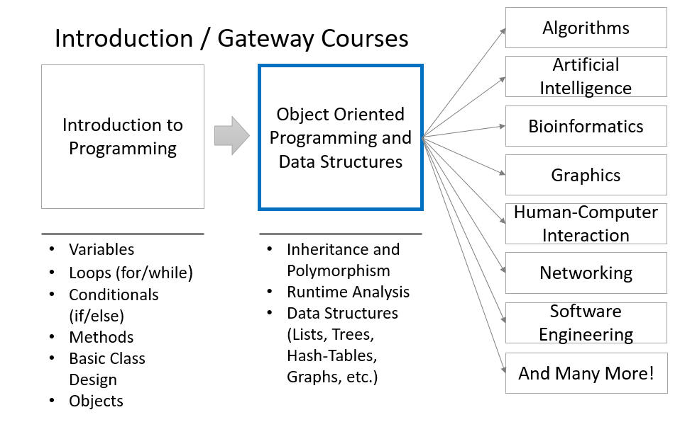

Notice first that this course assumes you are already familiar with the content in an "Introduction to Programming" course in some language (preferably Java). Notice second that the content in this specialization is often called a "**Gateway Course**" because: (1) its skills are so critical throughout computing that you need to have them before proceeding and (2) **having these skills opens doors to almost all areas of computing!**In fact, it is such a gateway that it is often the time computing learners can start internships in the field, hence the role of the fourth course on technical communication and interviews.

## **What are the courses in this specialization?**

You can find an outline of the courses below:

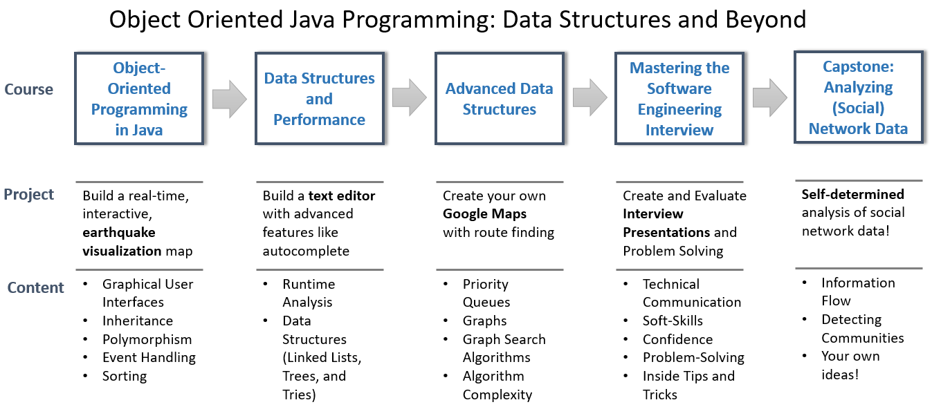

All of the courses have a real-world project connected to the key ideas of the course. We look forward to telling you more about the course, but first, let's see if it's the right fit for you.